**Kerala**

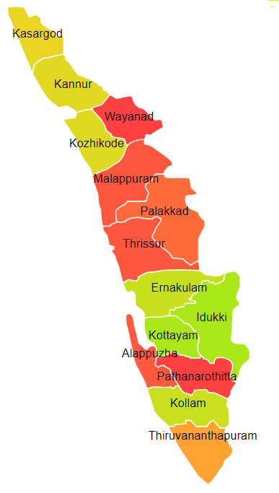

Kerala comprises of one Agro Ecological Region (AER) namely 19.

**Agro-Eco Region 19:** AER 19 in Kerala comprises of Alappuzha, Ernakulam, Idukki, Kannur, Kasargod, Kollam, Kottyam, Kozikod, Malappuram, Palakkad, Pattanamittia, Thiruvananthpuram, Trishur and Wayanad districts of Western Ghats & Coastal Plain under Agro Ecological Sub Regions (AESR) 19.2 & 19.3.